Information Management Metamodel (IMM) Specification

OMG Draft Specification: Revised Submission to the Request For Proposals
ab/05-12-02

Volume I
Introduction

OMG document: ad/2011-05-05

Date: May 23, 2011

Submitted by:
88solutions
Adaptive

International Business Machines (IBM)
KDM Analytics

Model Driven Solutions
No Magic
Sandpiper Software

Supported by:
Citigroup
Computer Associates
Cube Model
DAMA International
Embarcadero Technologies
Essential Strategies, Inc.
John Deere, Inc.
MEGA International
Michael J. Lynott
Oracle
MetLife
Gail Austin LLC
Rhysome
VISA

Primary Contact:
Harsh Sharma, Citigroup
hsharma@meta-guru.com
David Hay, DAMA International
commerce@essentialstrategies.com

Copyright © 1997-2011 88solutions
Copyright © 1997-2011 Adaptive
Copyright © 1997-2011 Cube Model
Copyright © 1997-2011 Embarcadero Technologies
Copyright © 1997-2011 International Business Machines (IBM)
Copyright © 1997-2011 KDM Analytics
Copyright © 1997-2011 MEGA International
Copyright © 1997-2011 Model Driven Solutions
Copyright © 1997-2011 No Magic
Copyright © 1997-2011 Sandpiper Software
Copyright © 1997-2011 Object Management Group.
Copyright © 2003-2011 Essential Strategies, Inc.

USE OF SPECIFICATION - TERMS, CONDITIONS & NOTICES
The material in this document details an Object Management Group specification in accordance with the terms, conditions and notices set forth below. This document does not represent a commitment to implement any portion of this specification in any company's products. The information contained in this document is subject to change without notice.

LICENSES
The companies listed above have granted to the Object Management Group, Inc. (OMG) a nonexclusive, royalty-free, paid up, worldwide license to copy and distribute this document and to modify this document and distribute copies of the modified version. Each of the copyright holders listed above has agreed that no person shall be deemed to have infringed the copyright in the included material of any such copyright holder by reason of having used the specification set forth herein or having conformed any computer software to the specification.
Subject to all of the terms and conditions below, the owners of the copyright in this specification hereby grant you a fully-paid up, non-exclusive, nontransferable, perpetual, worldwide license (without the right to sublicense), to use this specification to create and distribute software and special purpose specifications that are based upon this specification, and to use, copy, and distribute this specification as provided under the Copyright Act; provided that: (1) both the copyright notice identified above and this permission notice appear on any copies of this specification; (2) the use of the specifications is for informational purposes and will not be copied or posted on any network computer or broadcast in any media and will not be otherwise resold or transferred for commercial purposes; and (3) no modifications are made to this specification. This limited permission automatically terminates without notice if you breach any of these terms or conditions. Upon termination, you will destroy immediately any copies of the specifications in your possession or control.
PATENTS
The attention of adopters is directed to the possibility that compliance with or adoption of OMG specifications may require use of an invention covered by patent rights. OMG shall not be responsible for identifying patents for which a license may be required by any OMG specification, or for conducting legal inquiries into the legal validity or scope of those patents that are brought to its attention. OMG specifications are prospective and advisory only. Prospective users are responsible for protecting themselves against liability for infringement of patents.
GENERAL USE RESTRICTIONS
Any unauthorized use of this specification may violate copyright laws, trademark laws, and communications regulations and statutes. This document contains information which is protected by copyright. All Rights Reserved. No part of this work covered by copyright herein may be reproduced or used in any form or by any means--graphic, electronic, or mechanical, including photocopying, recording, taping, or information storage and retrieval systems--without permission of the copyright owner.

DISCLAIMER OF WARRANTY
WHILE THIS PUBLICATION IS BELIEVED TO BE ACCURATE, IT IS PROVIDED "AS IS" AND MAY CONTAIN ERRORS OR MISPRINTS. THE OBJECT MANAGEMENT GROUP AND THE COMPANIES LISTED ABOVE MAKE NO WARRANTY OF ANY KIND, EXPRESS OR IMPLIED, WITH REGARD TO THIS PUBLICATION, INCLUDING BUT NOT LIMITED TO ANY WARRANTY OF TITLE OR OWNERSHIP, IMPLIED WARRANTY OF MERCHANTABILITY OR WARRANTY OF FITNESS FOR A PARTICULAR PURPOSE OR USE. IN NO EVENT SHALL THE OBJECT MANAGEMENT GROUP OR ANY OF THE COMPANIES LISTED ABOVE BE LIABLE FOR ERRORS CONTAINED HEREIN OR FOR DIRECT, INDIRECT, INCIDENTAL, SPECIAL, CONSEQUENTIAL, RELIANCE OR COVER DAMAGES, INCLUDING LOSS OF PROFITS, REVENUE, DATA OR USE, INCURRED BY ANY USER OR ANY THIRD PARTY IN CONNECTION WITH THE FURNISHING, PERFORMANCE, OR USE OF THIS MATERIAL, EVEN IF ADVISED OF THE POSSIBILITY OF SUCH DAMAGES.
Table of Contents – Volume I
0. Submission Material 9
0.1 Submitters 9
0.2 Proof of Concept 9
0.3 Resolution of RFP requirements 10
0.4 Issues to be discussed 17
Changes to Existing OMG Specifications 19
XMI 2.4, ptc/2010-12-06 19
1. Scope 20
2. Conformance 23
3. Normative References 23
4. Terms and Definitions 23
5. Symbols 24
6. Additional Information 24
6.1 Specification Structure 24
6.2 Acknowledgements 25
7. Overview 27
7.1 Introduction 27
7.2 28
IMM In Context of The Zachman Framework 28
7.2.1 The Rows 28
7.2.2 The Columns 31
7.3. Migration From CWM 33
8.IMM Core 35
8.1 Introduction to the IMM Core Metamodel 35
8.2 IMM Core Metamodel 37
8.2.1 IMM Core: ‘Annotation’ Class Diagram 37
8.2.2 IMM Core: ‘Assertion’ Class Diagram 38
8.2.3 IMM Core: ‘Association’ Class Diagram 39
8.2.4 40
IMM Core: ‘Context’ Class Diagram 40
8.2.6 IMM Core: ‘Identifier Specification’ Class Diagram 41
8.2.7 IMM Core: ‘’Thing’ Class Diagram 42
8.2.8 IMM Core: ‘Link’ Class Diagram 43
8.2.9 IMM Core: ‘Modeled Concepts’ Class Diagram 44
8.2.10 IMM Core: ‘Multiplicity’ Class Diagram 46
8.2.11 IMM Core: ‘Naming Context’ Class Diagram 47
8.2.12 IMM Core: ‘Ordering Constraint’ Class Diagram 48
8.2.13 IMM Core: ‘Property’ Class Diagram 49
8.2.14 IMM Core: ‘Reference’ Class Diagram 50
8.2.15 IMM Core: ‘Template’ Class Diagram 51
8.2.16 IMM Core: ‘Type’ Class Diagram 52
8.2.17 IMM Core ‘Keying’ Class Diagram 53
8.3 IMM Core: Entity Relationship Model of EU-Rent example 54

Table of Tables and Figures
Table 1: Submitters 8
Table 2: RFP Requirements and Responses 9
Figure 1: IMM Coverage 17
Figure 2 An overview of IMM Metamodels 18
Figure 2: Data and Metadata 22
Figure 3: The Architecture Framework 25
Table 3: Carry-forward Components of CWM 31
Table 3: Carry-forward Components of CWM (cont.) 32
Figure 4 From Full Mesh to Hub and Spoke 33
Figure 5 Comprised Concepts 34
Figure 6: Annotations 35
Figure 7: Assertions 36
Figure 8: Associations 38
Figure 9: Composite 39
Figure 10: Class diagram of ‘Context’ 41
Figure 11: Identifier Specifications 42
Figure 12: Individuals 43
Figure 13: Links 44
Figure 14: Modeled Concepts 45
Figure 15: Multiplicity 46
Figure 16: Naming Contexts 47
Figure 17: Ordering Constraints 48
Figure 18: Properties 49
Figure 19: Reference 50
Figure 20: Templates 51
Figure 21: Types 52
Figure 22: ER Model of EU-Rent Example 54
PART I

Submission Material

Submitters
Table 1 shows companies who are formal Submitters, with contact points given:
Table 2: Submitters
Company | Contact | Email
88solutions | Manfred Koethe | koethe@88solutions.com
Adaptive | Pete Rivett | pete.rivett@adaptive.com
International Business Machines (IBM) | Der Ping Chou | dpchou@us.ibm.com
KDM Analytics | Nikolai Mansurov | nick@kdmanalytics.com
Model Driven Solutions | Cory Casenave | cory-c@modeldriven.com
No Magic | Tomas Juknevicius | tomasjkn@nomagic.com
Sandpiper Software | Elisa Kendall | ekendall@sandsoft.com

0.2 Proof of Concept
The Relational Database and XML Schema metamodels are based on the Eclipse metamodels which have mature implementations not only of the metamodel but added-value tooling.
An additional Eclipse project has already been established for the implementation of IMM.
All the UML Profiles have been successfully implemented in MagicDraw.

0.3 Resolution of RFP requirements
Table 3 shows the requirements originally specified in RFP for Information Management Metamodel, along with the responses in this document.
Table 4: RFP Requirements and Responses
IMM RFP Requirement | Response
6.5 Mandatory Requirements
6.5.1. Metamodel
a. Proposals shall contain an Information Management Metamodel (IMM), compliant with CMOF, and depicted using UML2 notation with normative form in MOF2 XMI. | The metamodel proposed is a MOF 2.4 metamodel depicted using UML2.4 The accompanying XMI files are XMI 2.4
b. The scope of the metamodel shall be at least as great as CWM 1.1 (see IMM RFP 05-12-02, section 6.2 for a guide to expected coverage of CWM). | The metamodel includes all of CWM (see Section 7.1) with the exception of Data Mining.
c. This metamodel shall reuse, and where necessary extend, relevant parts of the UML2 metamodel. | The UML2 metamodel is not used.
d. Where other OMG standard metamodels (those listed in RFP section 6.3) cover the same scope then IMM shall integrate with, rather than duplicating, those metamodels. | IMM is designed to link with, and complement, ODM and SBVR.  (See Volume II, Section 2.6.)
e. However it shall be possible to use IMM ‘standalone’ without requiring implementations compliant with those other standards. | However ODM and SBVR are not required.
f. The metamodel shall be modular: the packages should be usable in part, and reusable with other metamodels. | IMM consists of a number of packages with minimal interdependencies.

g. Submissions shall contain a number of compliance points allowing compliant tools to support identified packages, or subsets of the complete IMM: see RFP, section 6.1.7 for more detail. | See Section 7, below for compliance points.

6.5.2 Relational Metamodel and Profile
a. The IMM shall include Package(s) for Relational Database modeling. | This is included, see Volume III, Section 1 Error: Reference source not found
b. This shall be a PSM for the Relational platform and be capable of representing all non-syntactic aspects of SQL92 Data Definition Language (at the ‘intermediate’ conformance level). | It is based on the Eclipse SQL metamodel which in turn was directly based on the SQL Standard.
c. The metamodel shall also be capable of representing all aspects of the IE and IDEF1X notations. | All aspects that can be represented in Relational diagrams for these notations can be represented..
d. The Relational Model shall be transformable to SQL92 DDL. | This is a capability of the Eclipse Database Tools project based on the same metamodel.
e. Proposals shall contain a UML2 Profile for Relational data modeling, documented using the notation recommended in the UML2 Specification and with its normative form in UML2 XMI. | This is included: see Error: Reference source not foundVolume III, Section 1.5
f. the Relational Profile shall be mapped to the Relational Metamodel. | See Error: Reference source not found??

6.5.3 Entity-Relationship Metamodel and Profile
a. The IMM shall include Package(s) for Entity Relationship modeling | See Volume II, Section 2Error: Reference source not found
b. The metamodel shall be capable of representing at minimum all aspects of the Chen notation [Chen]. | See Volume II, Section 2. It addresses Chen, Information Engineering, and Barker-Ellis notations
c. Proposals shall contain a UML2 Profile for Entity Relationship modeling, documented using the notation recommended in the UML2 Specification and with its normative form in UML2 XMI. | See Volume II, Section 2.4.
d. The Entity Relationship Profile shall be mapped to the Entity Relationship Metamodel. | See Volume II, Section 2.4.

6.5.4 XML Metamodel and Profile
a. The IMM shall include Package(s) for XML Data modeling capable of representing all non-syntactic aspects of the XML Schema 1.0 XML language. | See Volume III, Section 2Error: Reference source not found.
b. The metamodel shall closely match the XML Schema metamodel in the XMI specification and replace it | This is based on the Eclipse XML Schema metamodel and was previously contained in the XMI specification.
c. Instances of the XML Metamodel shall be transformable to XML Schemas. | This is implemented by the Eclipse XSD project.
d. Proposals shall contain a UML2 Profile for XML data modeling, documented using the notation recommended in the UML2 Specification and with its normative form in UML2 XMI. | See Volume III, Section Error: Reference source not found2
e. The XML Profile shall be mapped to the XML Metamodel.

6.5.5 Resolution of Deferred CWM Issues
Proposals shall review and resolve outstanding CWM issues which include those listed in the subsections of the RFP section 6.1.5. | Not yet addressed.

6.6 Optional Requirements
6.6.1 Extended Record Metamodel and Profile
. [Note: The IMM must include Package(s) for basic Record modeling as part of meeting the mandatory requirement to provide forward migration for CWM 1.1.] | This is carried over from CWM.
a. The IMM may include an extended metamodel for record modeling that should be capable of representing all non-syntactic aspects of COBOL Data Divisions. | This is carried over from CWM Extensions.
b. The Extended Record Metamodel should be transformable to COBOL syntax. | This is not provided.
c. Proposals may contain a UML2 Profile for Record modeling, documented using the notation recommended in the UML2 Specification and with its normative form in UML2 XMI. | This is not provided.

d. The Record Profile should be mapped to the Record Metamodel (or the Extended Record Metamodel at the discretion of submitters). | Not applicable.

6.6.2 Object Oriented Database (OODB) Metamodel and Profile
a. The IMM may include a metamodel for modeling of object oriented databases (OODBs). | This is not provided: OMG now has an independent initiative for Object Databases.
b. The OODB Metamodel should be transformable to ODMG DDL syntax. | Not applicable
c. Proposals may contain a UML2 Profile for OODB modeling, documented using the notation recommended in the UML2 Specification and with its normative form in UML2 XMI. | Not applicable
d. The OODB Profile should be mapped to the OODB Metamodel. | Not applicable

6.6.3 Provision of Transformations
Where this RFP requests that models be ‘transformable’, submissions may supply the actual transformations - expressed in QVT and/or ModelToText as appropriate. | Transformations are not provided

6.6.4 Support for Methods
a. Submissions may include with the Relational Profile constraints to represent the rules of platform and particular methods e.g. IDEF1X | Such constraints are not provided.
b. Submissions may include with the Relational Profile shapes/icons matching the common notations of particular methods | Such icons are not provided

6.6.5 Relational Data Modeling Notation
Proposals may provide a normative definition of the relational modeling notation for the IE style of modeling. | This is not provided.

6.6.6 Representation of metamodel
Proposals may provide a non-normative representation of the IMM metamodel using one of the relational modeling notations. This would be to facilitate communication with the data modeling community. | Descriptive (non-normative) variants of the ER and Relational metamodels, and examples are shown using a UML-based variant of the Barker-Ellis notation.

6.6.7 Support for File Transfer as a type of data movement
Proposals may provide a means of representing the transfer of files between directories and/or machines as part of a Warehouse Process. | This is not provided.

0.4 Issues to be discussed
6.6.5 Relational Data Modeling Notation
Proposals shall specify a migration path from CWM 1.1 | This is provided in section 7 .
Proposals shall provide non-normative instance diagrams and accompanying explanatory text for each package and profile to show how their proposals can be used to represent simple but representative models | This has been done using the EU-Rent example, applied to all the different modules.
Proposals shall discuss their rationale for their selection of the parts of UML2 metamodel that were reused. | The UML2 was not re-used, except as the basis for the UML2 Profiles. The rationale is that UML2 contains too much ‘baggage’ and unneeded inheritance. The original Abstractions that were part of UML2 Infrastructure, which could have formed a basis of IMM, have not ended up as part of mainstream UML.
Proposals shall discuss and justify their approach for integrating the proposed IMM with the other OMG metamodels in 6.3 and how IMM can be used standalone. | The Traceability Metamodel provides the ability to link with ODM and SBVR.
Proposals shall discuss how to use QVT and Model to Text for the transformations (unless they have been provided in response to optional requirement 6.6.2). | As a MOF metamodel, IMM is amenable to these transformation technologies.
Proposals shall also discuss how to model and maintain manually created traceability links – for example from the logical Entity Relationship to physical Relational and XML models. | This is covered by the Traceability metamodel designed for this purpose.
Proposals shall discuss how the proposed IMM metamodel could be extended (this shall also address CWM Issue 4583). | The metamodel and profiles can be extended using UML: either by inheritance or creating associations

PART III

Changes to Existing OMG Specifications

XMI 2.4, ptc/2010-12-06
The XML Schema Metamodel in IMM subsumes that included in the XMI 2.4 specification, so it should be removed from the latter. It is an isolated chapter with no dependencies to or from other material in XMI, nor any compliance points. As the final chapter, its removal does not even require any section renumbering.
In fact both the metamodel and its replacement in IMM are based on the same Eclipse XSD metamodel and so are virtually identical except for the versions of UML/MOF used.

Editing instructions
Remove chapter 10, XML Schema Infoset Model
PART II

Scope
The Information Management Metamodel provides a metamodel and UML profiles for modeling and management of information resources at any level, and as such is a cornerstone of MDA along with UML and MOF. It supersedes OMG’s Common Warehouse Metamodel (CWM).
The scope includes:
- Representation of information models at conceptual, logical and physical levels
- Representation of the traceability/dependency relationships between the models at these different levels
- Mapping of physical models to implementation artifacts such as SQL, XML Schema.
- Mapping to business vocabulary and semantic models (respectively modeled via the separate Semantics of Business Vocabulary and Rules and Ontology Definition Metamodel standards)
- Usage for detailed resource definitions in diverse OMG standards such as Service Oriented Architecture Modeling Language (SoaML) and Business Process Model and Notation (BPMN)
- Models for the management of the resources, including business responsibility/stewardship and physical data movement

For mapping purposes, IMM includes a Core Metamodel: this provides a generic representation of any of the resource models, allowing mappings to be defined in a ‘hub and spoke’ rather than a ‘many to many’ manner.

The coverage of IMM is illustrated by the diagram in Figure 1.

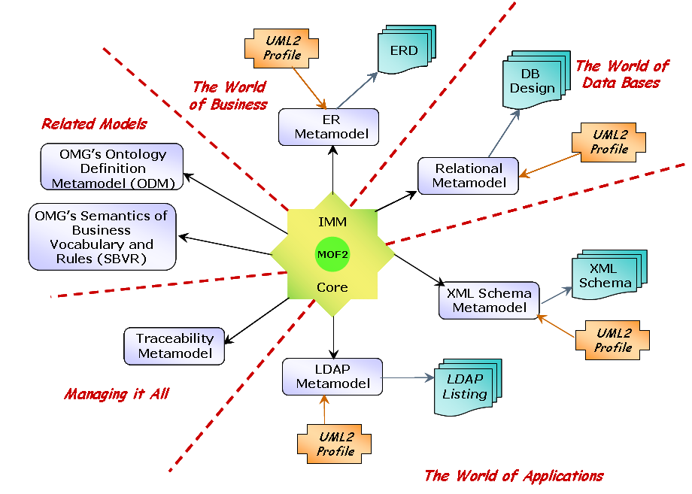

Figure 2: IMM Coverage

IMM consists of a set of metamodels that address business and technology view of Information management as well as aspects of model management (see Figure 2).

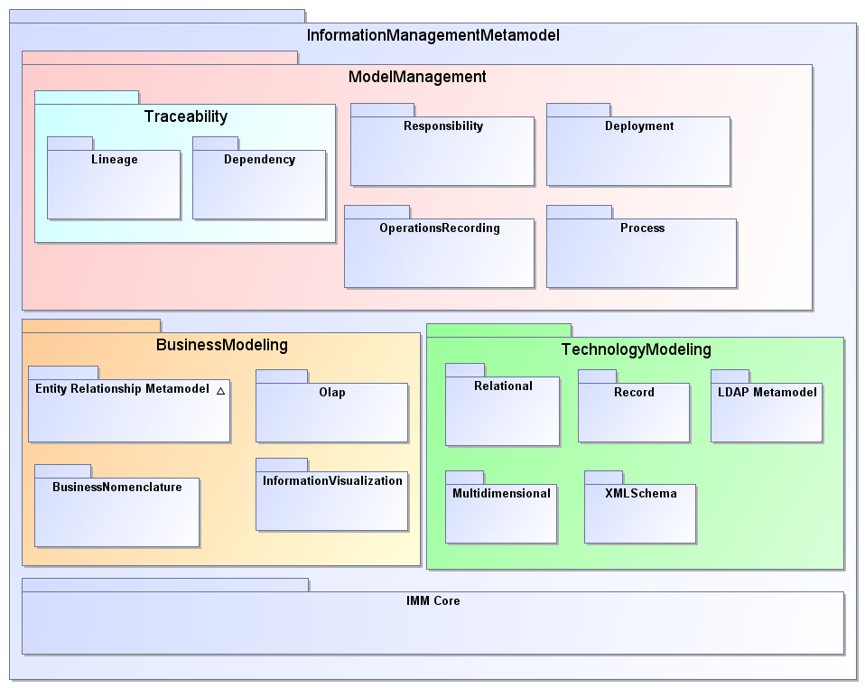

Figure 2 An overview of IMM Metamodels

Conformance
Each metamodel and profile constitutes a separate and independent conformance point, with the exception of those Descriptive Models for Relational Database and Entity-relationship which are marked as (Informative).
Software conforms to a metamodel or a profile through being able to import and export XMI corresponding to that metamodel or profile.

Normative References
- MOF 2.4 Specification
- XMI 2.4 Specification
- UML 2.4 Specification

Terms and Definitions
The following terms are used in different ways in different communities. The following define how they are used in this specification.
Conceptual Model A model containing important concepts for a particular purpose. It does not contain full detail of attributes (if they are included at all), keys or all relationships. Examples are a ER model with Entities and Relationships only or a UML model with Classes ands Associations only.
Data Definition Language (DDL) – The part of SQL (typically) used for declaring information structures (Tables, Columns, Schemas) as opposed to manipulating them.
IDEF 1X - Commonly used notation for logical models of relational databases, standardized by NIST See [IDEF1X FIPS184] and [IDEF1X Hayes].
Information Engineering (IE) Widely used traditional software development method, focused on data analysis. Includes a commonly used data modeling notation, most famous for using ‘crows feet’ to represent multiplicity.
Logical Model A model that fully represents all the information in terms of detail (including attribute names and types, relationship names and cardinalities), but independent of a realization in a particular (type of) platform. Compared to a physical model (q.v.) the data types will not be constrained to the platform and relationships will not be subject to platform constraints (for example many-to-many relationships are permitted). It will contain definitions of Keys where they represent groupings of identifying attributes/relationships but not indexes (which are for access purposes) or foreign keys (which are physical realizations of Relationships). Examples are a ‘pure’ UML Model (no profiles applied) or a fully-attributed, non-normalized ER model
ER Model A model of information primarily in terms of entities, relationships and attributes. An ER model may be used for a number of purposes which will constrain the level of detail and organization: for example conceptual model (q.v.), logical model (q.v.) or physical model (q.v.)
Mapping Specification of a mechanism for transforming the elements of a model conforming to a particular metamodel into elements of another model that conforms to another (possibly the same) metamodel.
Physical Model A model aligned to an implementation platform – such that each model element has a direct correspondence with an element in the platform. Examples are models of an XML Schema or relational database schema. When describing a physical model the specific platform should be included e.g. ‘A physical relational database model”.
Platform A set of subsystems/technologies that provide a coherent set of functionality through interfaces and specified usage patterns that any subsystem that depends on the platform can use without concern for the details of how the functionality provided by the platform is implemented.

Symbols
None.

Additional Information

6.1 Specification Structure
This submission document is divided into four volumes:
I. Introduction to IMM, including definitions of metadata, the framework used to organize it, other terms of reference and links to the Common Warehouse Metamodel (CWM).
II. This volume begins with a complete description of the IMM Core Metamodel. It also includes the Platform-independent metamodel (PIM) of Platform-independent (entity/relationship) modeling, plus the normative (platform-specific) metamodel of entity/relationship (PIM) modeling.. The first uses the entity/relationship version of UML (described in Section 2.2) notation, and the second uses standard UML.
III. Metamodels of various platform-specific modeling (PSM) approaches, including relational design, XML Schema design, and the Lightweight Directory Access Protocol (LDAP) are included in Volume III. This includes a platform independent (entity/relationship) model of relational database design, as well as normative (platform-specific) models of all approaches.
IV. Appendices:
- Appendix A: References
- Appendix B: Example of Moving from SBVR to Logical Model
- Appendix C: Example of Moving from Logical Model to Relational Database Design

6.2 Acknowledgements
The following contributed to, or commented, on this specification:
- Gail Austin
- Jeff Cahoon
- Dave Carlson
- Donald Chapin
- Der Ping Chou
- John Hall
- David Hay
- Kenn Hussey
- Tomas Juknevicius
- Greg Keller
- Jim Logan
- Pete Rivett
- Harsh Sharma

Overview

Introduction
The software development life-cycle often starts with a business analyst gathering requirements from business users and (in some cases) translating them into Use Case Diagrams. These are passed on to the application developers who may use object-oriented modeling to develop UML structural and behavior diagrams and optionally generate application code.
In many scenarios these artifacts are simply used to document the system to be built. In case a database is required, data analysts/data modelers will approach the same business user and gather data oriented requirements and start developing database designs (analytical or transactional) etc. More recently, with the advent of XML, the XML developers may approach the same business users and try to develop XML Schemas for mapping disparate data sources to a domain-specific XML Schema and deliver the data via web services.
These tracks, often disconnected, conducted in parallel, lead to same set of requirements being modeled in different modeling/design paradigms/tools and create metadata that could lead to the same requirements/concepts (business and technical) being interpreted differently (semantically) as well as incompatible formats. Ultimately this translates into missed deadlines, disconnected software development life-cycle, poor software quality and higher development costs.
Historically, the gap between object oriented, data and XML modelers has continued to exist with each side sticking to its comfort zone. Every now and then end-users and tool vendors have expressed the desire to bridge these gaps but ended up defining their own tool-specific profiles for each. As a result, there is neither an accepted standard nor interoperability of models developed using such profiles or tools.
One aim of the Information Management Metamodel (IMM) is to bridge the gap between the UML, data and XML modeling worlds. The data modeling community still has quite a high level of resistance to the UML notation: the vision of IMM is to allow tools to switch between UML and the other notations as easily as tools today allow switching between IDEF-1X and (some variant of) Information Engineering (IE). This will have significant benefits for improved communication between different communities (even database designers and developers in the same organization).
OMG’s Common Warehouse Metamodel (CWM,2003) has been successful and is mature and stable, with widespread and increasing adoption by vendors and customers for metadata interchange: most widely in the area of relational database information. The uptake has been somewhat hampered by CWM’s name – many of the potential uses of CWM have no connection with building or managing data warehouses. Hence the proposed name for the new standard is Information Management Metamodel instead of CWM 2.x.

7.2

IMM In Context of The Zachman Framework
Because the model presented here is intended to represent the information management industry as a whole, an Architecture Framework is needed to organize the body of knowledge concerned. The Architecture Framework used here is based on John Zachman’s 1987 and 1992 “Enterprise Architecture Framework” [Zachman, 1987, Sowa and Zachman, 1992].
The Zachman Framework consists of a matrix, where the rows represent perspectives different people have on an information technology project, and the columns represent what they are seeing from each perspective: Data, activities, locations, people and organizations, timing, and motivation.
(The Architecture Framework used here uses the same matrix, but differs slightly in its definition of rows from Mr. Zachman’s version. Even so, the principal concepts are the same. This will be described below.)

The Architecture Framework is diagrammed in Figure 1-5. The rows in the Framework represent the perspectives of different actors in the system development process, and the columns represent the things viewed from each perspective. While the concepts are the same, some of the names of rows are different from those used by Mr. Zachman in his original paper.

The Rows
Each row represents a point of view of one of the categories of players in the systems development process, while each column represents a different aspect of the process. The perspectives are:
1. Scope Boundaries (Strategist’s view): This defines the enterprise’s direction and business purpose. This is necessary in order to establish the context for any system development effort. It includes definitions of the boundaries of system or other development projects.
2. Business Semantics (Executive Leader’s view): This defines—in business terms—the nature of the business, including its structure, processes, organization, and so forth. There are usually multiple business owners’ views of a given enterprise, and these may overlap or even contradict each other. These Business Owners’ views may be classified into two groups:
- Views of the tangible current nature of the business: Most people in a business are concerned with the specific organization, computer systems, forms, and procedures required to carry out a business the way it exists now. This view of the world constitutes what the American National Standards Institute in 1975 called the external schema. [ANSI, 1975]
- A single view of the underlying nature of the business: individual things seen by each business owner are usually examples of more general, more fundamental (if more abstract) things. This view is relatively abstract, although it is not yet structured to use as the basis for designing computer systems. This is the beginning of the conceptual schema (model) of the business. [ANSI, 1975]
The essence of this row is its capture of the semantics of the organization. That is, this row is about the vocabulary of the business as seen by the business owners.
OMG has addressed the Inventory part of this row with its standard “The Semantics of Business and Vocabulary Rules”. The OMG has also addressed the Motivation part with standard “Business Motivation Model”.
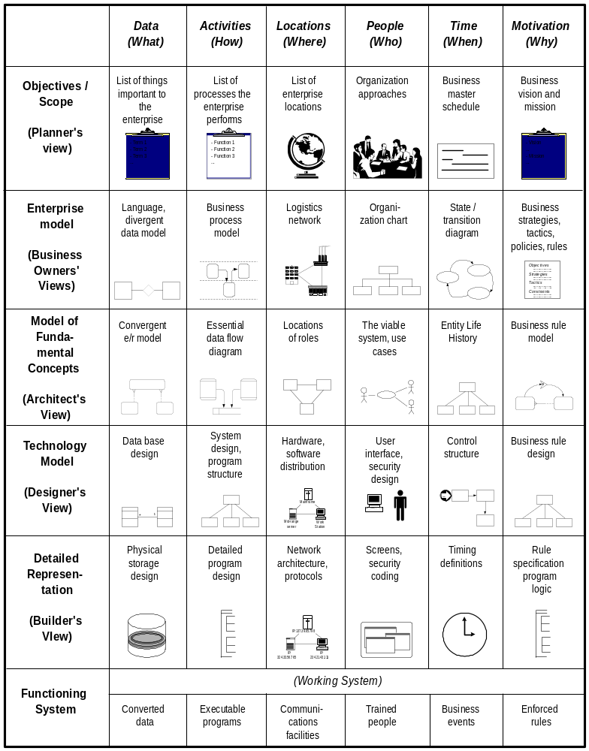
Figure 6: The Architecture Framework
3. System Schematics (Architect’s view): This perspective sees the underlying structures of Row Two rendered in a more disciplined fashion, completing the conceptual model of the business. This is still without reference to any particular technology. The word “system” in this case refers not to a computer system, but the system of components that constitutes the enterprise.
For example, Executives’ views of business rules encompass all constraints that might be imposed on a business, while the Architect’s view is only of constraints that affect the updating of data or the processes of doing such updating. An Exective’s view of data can include many-to-many relationships, relationships among three or more entity classes (n-ary relationships), and multi-valued attributes. The Architect’s perspective eliminates all of these.
4. Technology specification (Engineer’s view): This describes how technology may be used to address the information-processing needs identified in the previous rows above. Here object-oriented databases are chosen over relational ones (or vice versa), kinds of programming languages are selected (3d or 4th generation, object-oriented, etc.), program structures are defined, user interfaces are specified, and so forth.
The three views above are views of the business. This is the first view that is of information technology.
The ANSI view of data called this the logical schema [ANSI, 1975], but in later years this has taken on the name “physical model”. This fourth row is abour the person who designs new artifacts, not the one who constructs them.
5. Component instructions (Implementer’s view): The implementer sees the details of a particular language, database storage specifications, networks, and so forth. This is what ANSI called the physical schema [ANSI, 1975]
- Operations world (Worker’s view): Finally, a new view is presented to the organization in the form of a new system. This is the view of the inventory of actual computer systems and databases installed in particular places. A single system design from Row Four may be implemented in numerous Functioning Systems.

7.2.2 The Columns
Each column in the architecture framework represents an area of interest for each perspective. The columns describe the dimensions of the systems development effort. The column of relevance for IMM is:
- Inventory (what): Each of the rows in this column addresses understanding and dealing with the things of significance to an enterprise, about which information is to be held. In Row One, this is about the most significant objects treated by the enterprise. In Row Two, it is about the language used—terms, facts, and definitions—and in Row Three it is about specifically defined data entity classes and their relationships to each other. Row Four concerns the representation of data by computer software and database management systems. This may be in terms of tables and columns, object classes, or the artifacts of any other system development approach. In Row Five, this is about the way data are physically stored on the computer with a particular data management technology. This row is described in terms of tablespaces, disk drive cylinders, and so forth. Row Six is about the physical inventory of databases.

Specifically, the model is organized as follows:
- Row Two is concerned with the language of the business. It deals with concepts, facts, words, and symbols. This part of the model is addressed by SBVR and by the Business Nomenclature module of IMM.
- Row Three is about the conceptual data model. That is, it is concerned with entity classes, attributes, and relationships that describe the things of significance to a business in rigorous terms. These are in fact sub-types of the concepts described in Row Two.
- Row Four describes the structure of data as used for a particular technology. In the first three rows, the nature of the business is being described, while here models are of design artifacts—either relational database tables or object-oriented design classes. The tables or classes in this row are fundamentally different from the entity classes that appear in Row Three.
- The technology chosen affects the metamodel on this row. The model of relational database design is different from the model of XML schemas.
- Note that UML was originally intended as a way to model object-oriented designs in Row Four. That some of the symbols in a UML class diagram can also be used to create a Row Three logical model does not change the fact that the meaning of a Row Three model is fundamentally different from that of a Row Four model.
- Row Five represents the actual SQL definitions used to create a database, XML schema etc.
- Row Six describes the actual instances of tables and columns that constitute a real database and is outside the scope.

7.3. Migration From CWM
This section outlines the IMM equivalent of the different parts of CWM.
Table 6: IMM Equivalents for CWM
Current CWM layer | Current CWM Package | IMM Metamodel/Other OMG Standard | Comments
Management

 | Warehouse Operation | ModelManagement.  OperationsRecording
 | Warehouse Process | ModelManagement.  Process
Analysis
 | Transformation | Traceability.  Lineage | CWM Transformation Package is renamed to Lineage
 | OLAP | BusinessModeling.  OLAP
 | Data Mining |  | Data mining package was deemed too large and unique enough to be considered as a separate future standard. Therefore, it is not included in IMM.
 | Business Nomenclature | BusinessModeling.  BusinessNomenclature
Table 3: Carry-forward Components of CWM (cont.)
Current CWM layer | Current CWM Package | IMM Metamodel/Other OMG Standard | Comments
 | Information Visualization | BusinessModeling.  Visualization
Resource
 | Object Model | IMM Core | IMM Core
 | Record | TechnologyModeling.  Record
 | Relational | TechnologyModeling.  Relational | IMM Relational Metamodel is based on Eclipse SQL metamodel
 | Multidimensional | TechnologyModeling.  Multidimensional
 | XML | TechnologyModeling.  XML Schema | IMM XML Schema metamodel is based on Eclipse XML Metamodel
Foundation
 | Business Information | ModelManagement.  Responsibility | Is it covered by the ER metamodel and SBVR? Combined??
 | Data Types | IMM Core and Relational | See Appendix… for mapping of Data Types across IMM Metamodels
 | Expression | IMM Core
 | Keys and Indexes | IMM Core, Relational metamodel
 | Type Mapping | IMM Core
 | Software Deployment | ModelManagement.  Deployment

8.IMM Core

8.1 Introduction to the IMM Core Metamodel

The IMM Core metamodel contains packages, classes and associations that form core of the IMM standard and used by rest of the IMM metamodels. Modeling concepts described in IMM Core should enable development of models to manage structured, un-structured, XML and other types of information. In addition, other OMG metamodels such as Ontology Definition Metamodel should be able to use IMM without forcing them to change.
IMM Core permits a hub and spoke approach to interoperability between many different metamodels. These metamodels provide the specific type vocabulary for storing conceptual models, logical models, and physical models of data. As shown in Figure 4, the IMM Core Metamodel provides the hub of a hub-and-spoke architecture that makes it unnecessary to map every metamodel to every other metamodel. Instead, a subset of each metamodel is transformable into and out of the core, which allows, for example, an ER model to transform into the core and then transform out to a relational model, with some rule-based augmentation to fill in any gaps.

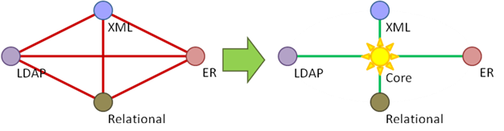

Figure 7 From Many-to-Many to Hub and Spoke

Through this hub-and-spoke architecture, the IMM Core provides several other benefits. It provides a common language for mapping between specific metamodels, transforming models, and tracing the lineage of model elements; it makes transformations reusable (e.g., transforming an ER model into an XML schema has much in common with transforming a relational database model into an XML schema); and it reduces point-to-point transformations to far fewer hub and spoke transformations.
As depicted in Figure 5, the IMM Core comprises concepts that are common to all the metamodels, such as Attribute, Association, and Thing Type, as well as concepts that are only common to some metamodels and can be mixed-in as needed, such as Identifier Specification, Reference, and Composition. The IMM Core does not provide the more technology-specific concepts: specific metamodels add those by either specializing the IMM Core or mapping to it.
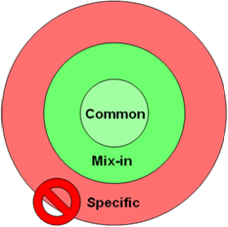
:

Figure 8 Core Concepts
The IMM Core uses a faceted approach to representing data models. Nearly all of the concepts in the IMM Core are instantiated only when needed—even including element names—in a particular context. This allows a great deal of flexibility. For example, an ER model represented in the IMM Core may have an association between a “Rental Movement” and a “Rental”, while a relational schema represented in the IMM Core might augment an association end with primary keys and foreign keys to specify how a table realizes the association end. Both projections could co-exist as instantiations of concepts in the IMM Core at the same time, in two different contexts, although this is not always necessary.
To date we have been expressing examples using UML 2 instance specifications. To create real instances of the IMM Core Metamodel for these examples, we need to represent these instances in the Meta Object Facility (MOF). This works until we need to add or mix-in a type, or facet; as we do, for example, to express how a relational database table realizes an association end. UML instance specifications are able to support multiple types or facets per instance, but MOF is not. We also need to be able to add these facets in MOF dynamically during a transformation.

8.2 IMM Core Metamodel
The IMM core metamodel description has 16 diagrams, each describing a different aspect of the metamodel. Each of the following sections contains a diagram using a two-color scheme for its classes and a description of the classes that are defined on that diagram. An orange class is one that is defined completely, in terms of its generalizations, specializations, associations, and textual definition. A white meta-class is one that merely helps to define an orange class. (With the metamodel loaded in the original modeling tool, one can double click a white class to navigate to its defining diagram.)

8.2.1 IMM Core: ‘Annotation’ Class Diagram
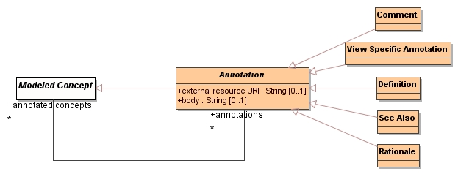
Figure 9: Annotations

Classes
- Annotation - Modeled information for which the semantics are undefined in the model, such as a comment.
- Comment – Description or notes
- View Specific Annotation - A rendering-specific annotation, such as diagram interchange information.
- Definition – The formal meaning of the concept
- See Also – Additional information
- Rationale - The reason a particular concept was modeled.

8.2.2 IMM Core: ‘Assertion’ Class Diagram
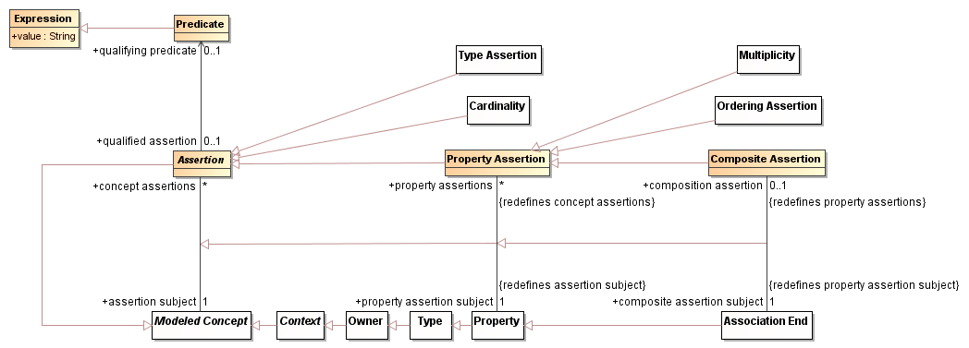
Figure 10: Assertions

Classes
- Assertion - Any statement about a modeled concept. When the qualifying predicate is set, the assertion will only apply when it evaluates to true.
- Category Assertion - Constraints on the individuals of the type.
- Value Specification - The computation or selection of an individual.
- Predicate - Value specification that must return true or false. Intended to be a constraint on other forms of value specifications. Should be done with a parameterized type.
- Property Assertion - Any assertion about a property, such as multiplicity or ordering.

8.2.3 IMM Core: ‘Association’ Class Diagram
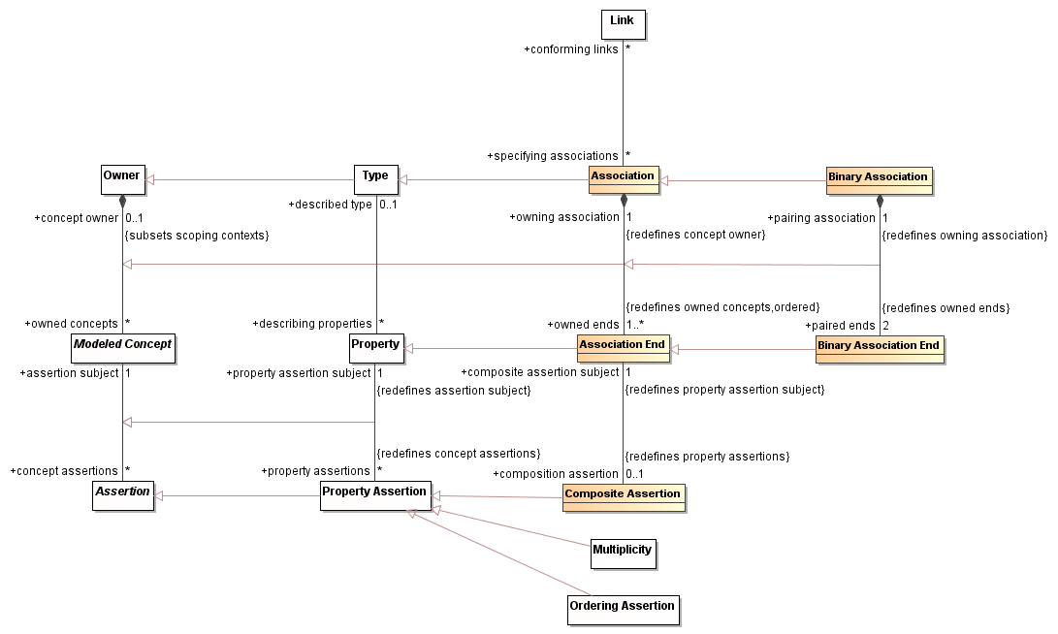
Figure 11: Associations

Classes
- Association - An association is a type of semantic relationship that can occur between denotable things. It has at least one end, each of which references a type. More than one end of the association may reference the same type. Conforming to an association provides the semantics for the connections between the denotable things.
- Binary Association - A binary association is a type of semantic relationship that can occur between exactly two denotable things. It has two ends, each of which references a type. More than one end of the association may reference the same type.
Conforming to an association provides the semantics for the connections between the denotable things.
- Association End - A binary association end is the part of a binary association that specifies the type to which it connects and other constraints for the denotable things to which is connects.
- Binary Association End - A binary association end is a kind of association end that is paired by a binary association. A binary association end is necessary because a property needs to be able to navigate to the "other end" of an association, and only a binary association end can guarantee that this "other end" exists.

8.2.4

IMM Core: ‘Context’ Class Diagram
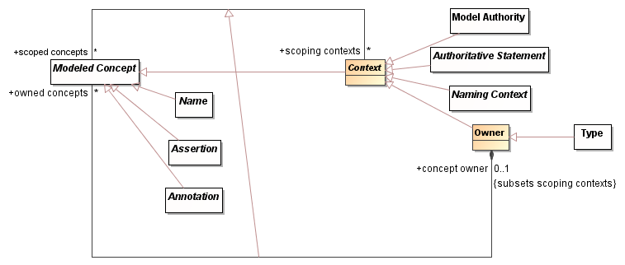
Figure 13: Class diagram of ‘Context’

Classes:
- Context - A context is anything that defines an area of concern for other modeled concepts. Any set of concepts can be scoped by or depend on a context.
- Owner - An owner is a kind of Context that may own Modeled Concepts.
In English it is normal to talk about something being “in a context”. As in “fish in the context of natural resources”. In this sense “Natural resources” is being used as a context and the subject “fish” are being related to that context. Being “in a context” provides scope as to the sense of the term being used and the aspect of the subject under consideration. The intent of context seems to be highly related to selecting the sense, scope and aspect of something being considered.

8.2.6 IMM Core: ‘Identifier Specification’ Class Diagram
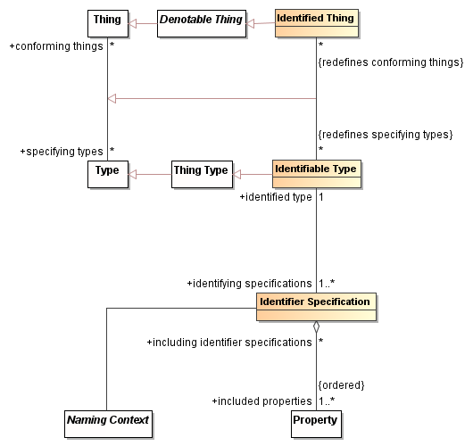
Figure 14: Identifier Specifications

Classes
- Identified Thing - An instance that is explicitly denoted, as one or more of the identifying types to which it conforms specifies with an identifier specification.
- Identifiable Type - A type whose instances are explicitly denoted with an identifier, which may be specified in some number of identifier specifications.
- Identifier Specification - A specification of which properties make up the unique name of an explicitly denoted thing.

8.2.7 IMM Core: ‘’Thing’ Class Diagram
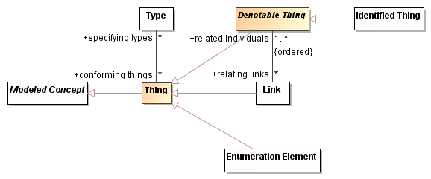
Figure 15: Individuals

Classes
- Denotable Thing - A thing that can be indicated, expressed, connoted, pictured, or described.
- Nothing - Nothing is used by OWL and other logic systems. All things are not nothing.
- Individual - Anything that is not nothing. May satisfy zero or more types. AKA: Thing

8.2.8 IMM Core: ‘Link’ Class Diagram
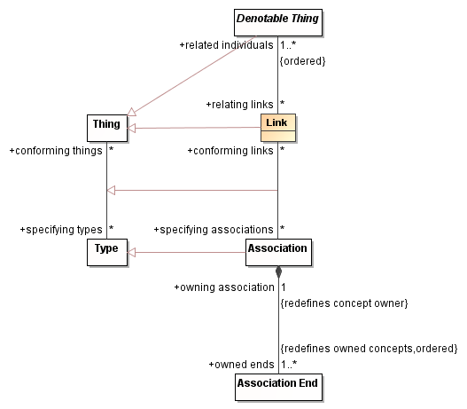
Figure 16: Links

Classes
- Link - A link is the connection between two or more individuals that may conform to one or more associations. Although very similar, a link is not an individual because it cannot link links.

8.2.9 IMM Core: ‘Modeled Concepts’ Class Diagram
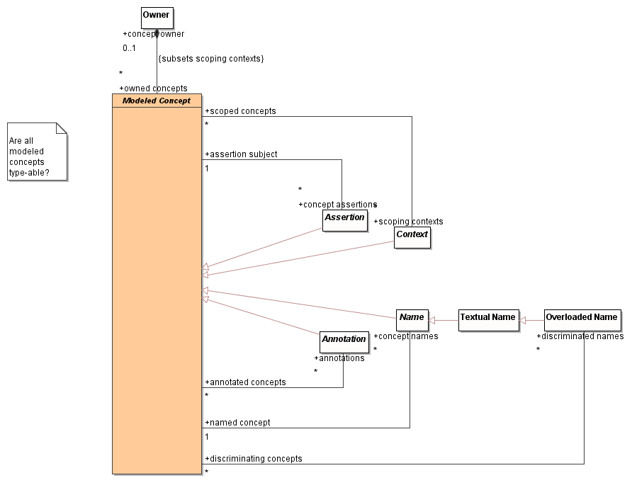
Figure 17: Modeled Concepts

Classes:
- Modeled Concept - Anything in a model

8.2.10 IMM Core: ‘Multiplicity’ Class Diagram
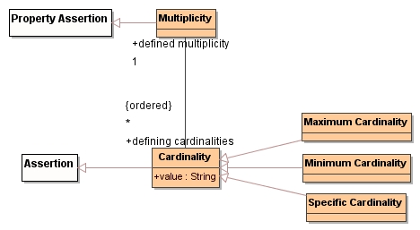
Figure 18: Multiplicity

Classes
- Multiplicity - A set of cardinalities that define all the possible numbers of elements in a set or group.
- Cardinality - The number of elements in a set or group.
- Maximum Cardinality - The maximum number of elements in a set or group.
- Minimum Cardinality - The minimum number of elements in a set or group.
- Specific Cardinality - The specific number of elements in a set or group.

8.2.11 IMM Core: ‘Naming Context’ Class Diagram
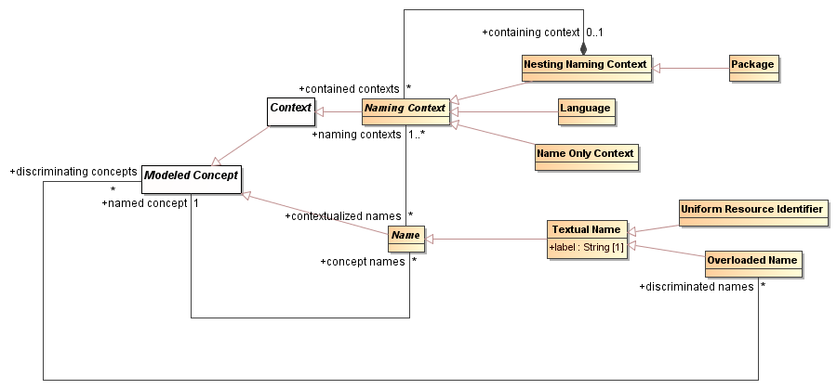
Figure 19: Naming Contexts

Classes:
- Name - Binds a symbol or identity to a modeled concept in a context.
- Textual Name - Binds a textual symbol to a modeled concept in a context.
- Uniform Resource Identifier - A string of characters used to identify or name a resource.
- Overloaded Name - A name such as an overloaded UML operation.
- Naming Context - A context or scope for defining names.
- Nesting Naming Context - A namespace that can contain other namespaces
- Package - A recursive, aggregated context for names.
- Language - A way to identify the language used to name model elements. The language may be a spoken language, modeling language, implementation language, UML Profile, or EDOC Aspect. For example, a given modeled concept might have a name per spoken language.
- Name Only Context - A context used exclusively to define names, such as a URI namespace.

8.2.12 IMM Core: ‘Ordering Constraint’ Class Diagram
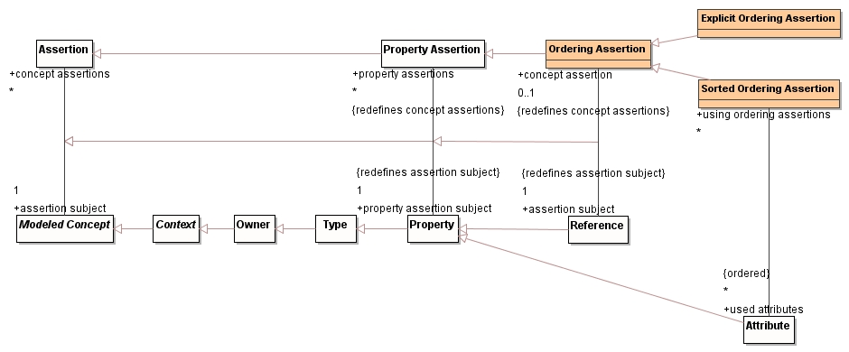
Figure 20: Ordering Constraints

Classes
- Ordering Assertion - Asserts a reference's instances are ordered.
- Explicit Ordering Assertion - Same as UML isOrdered.
- Sorted Ordering Assertion - Asserts that instances of the reference are ordered using a set of attributes.

8.2.13 IMM Core: ‘Property’ Class Diagram

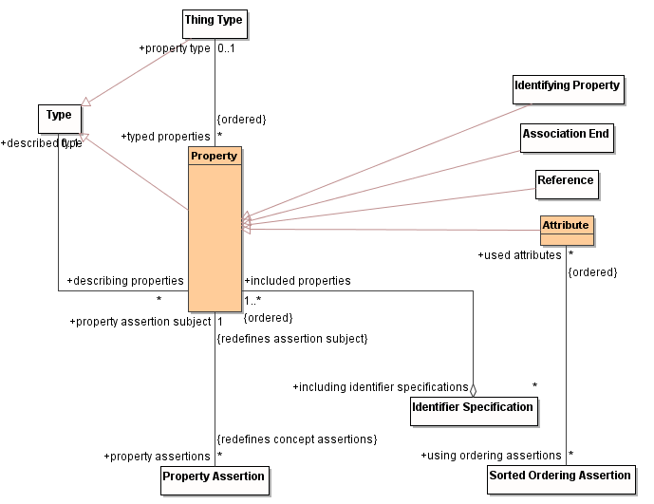
Figure 21: Properties

Classes
- Property - An association end, attribute, reference, or identifying property having an explicit domain and range. See RDF-S for definitions of domain and range.
- Attribute – An attribute is a property that is not part of an association.

8.2.14 IMM Core: ‘Reference’ Class Diagram
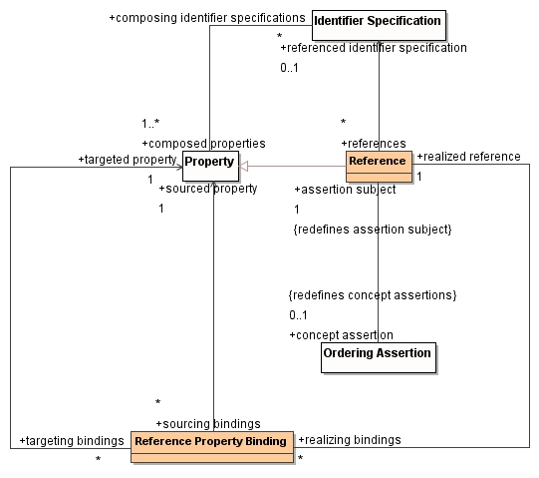
Figure 22: Reference

Classes
- Reference Property Binding - A pairing of properties in the source and target types that realize a reference, which provides the foundation for building primary keys and foreign keys.
- Reference - A property that references another type, possibly via an identifier specification and reference property bindings.

8.2.15 IMM Core: ‘Template’ Class Diagram
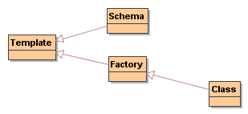
Figure 23: Templates

Classes
- Template -
- Schema -
- Factory -
- Class - A type with properties that can create conforming instances.

8.2.16 IMM Core: ‘Type’ Class Diagram
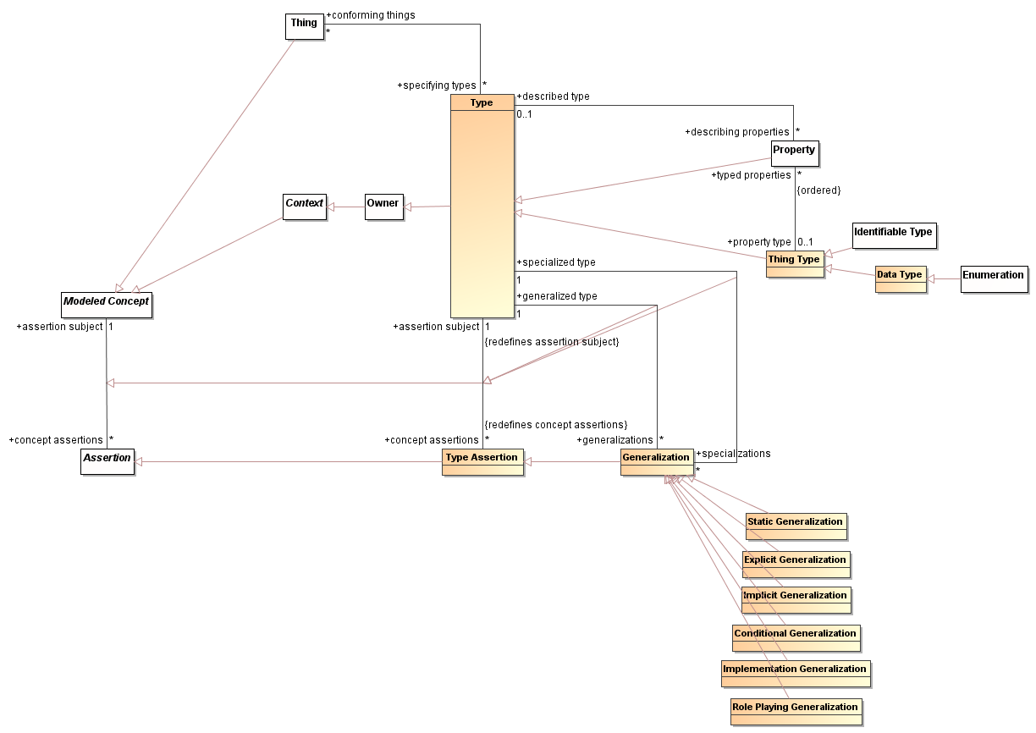
Figure 24: Types

Classes
- Type - A type is a specification for a set of individuals that conform to it. The set may be defined by features, characteristics, by a predicate or be an explicit set. An individual may conform to multiple types at the same time and the set of types an individual conforms to with may change over time. The concept of class, in the object oriented sense, is one kind of type where the type also acts as the factory of instances of that type.
- Data Type - A data type defines a value type that does not have a distinct identity, other than the value itself.
- Enumeration - An enumeration is a data type whose values are enumerated in the model as enumeration literals.
- Type Assertion - Any statement about a type.
- Generalization - The common concept of generalization. All denotable things that comply with the super-type also comply with the subtype.
- Static Generalization - A denotable thing can have one type and it cannot change.
- Explicit Generalization - The nominated new type may be added to an existing denotable thing based on an explicit statement.
- Implicit Generalization - A denotable thing assumes this type when it is in the role of the type.
- Conditional Generalization - A denotable thing will assume the type when a condition (if any) is met.
- Implementation Generalization - A denotable thing implements or realizes a type.
- Role Playing Generalization - A behavior that a type can take on dynamically, i.e., an EDOC role. For example, a customer is a role of a person.

8.2.17 IMM Core ‘Keying’ Class Diagram
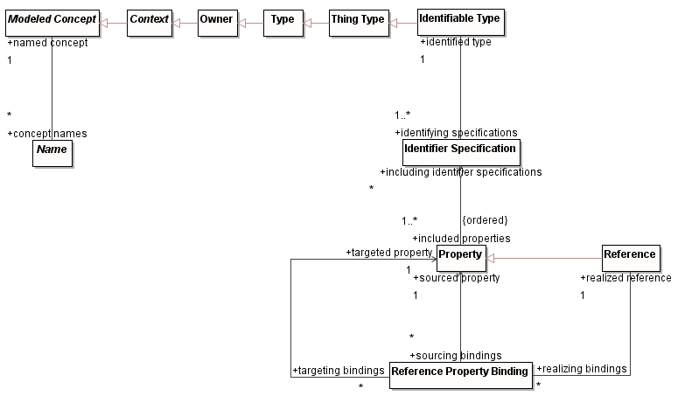

8.3 IMM Core: Entity Relationship Model of EU-Rent example
The Semantics of Business Vocabulary and Business Rules (SBVR) specification includes a case study describing a fictional car rental company with the name “EU-Rent” (pronounce “Yoo-rent”). This specification will use examples derived from that case study, starting with Figure 18. Subsequent sections use this example to illustrate the different metamodels.
The following diagram is an example of how a portion of the EU-Rent model would look if it were instantiated in the ER metamodel and then transformed into the core metamodel. It shows an example of a normal attribute, an identifying attribute, a generalization relationship, and a binary association.
Working vaguely from the middle-top of the diagram to the bottom, an Identifiable Type is what represents the ER metamodel's "(ACTUAL) CAR MOVEMENT" entity type. Its name is stored as a Textual Name, and its attributes are stored as separate Attributes. Its "movement id" attribute is what identifies a particular instance of the entity type, and serves as a kind of unique name for the instance. We record this fact as a specialization of Name, called an Identifier Specification. Each Attribute has a multiplicity, indicating a specific cardinality of instances of the type.
A Static Generalization is what records the fact that "RENTAL MOVEMENT" is a specialization of "(ACTUAL) CAR MOVEMENT".
A Binary Association is what records the fact that there is a relationship between "(ACTUAL) CAR MOVEMENT" and "RENTAL MOVEMENT". The Binary Association has two Binary Association Ends representing the association roles. The name of one end is recorded with the label "the basis for", with a multiplicity having a minimum cardinality of zero and a maximum cardinality of "*". That end has "RENTAL MOVEMENT" as its property type, and "RENTAL" as the type it is describing. The name of the other end is recorded with the label "included in", with a multiplicity having a specific cardinality of "1". That end has "RENTAL" as its property type and "RENTAL MOVEMENT" as the type it is describing.
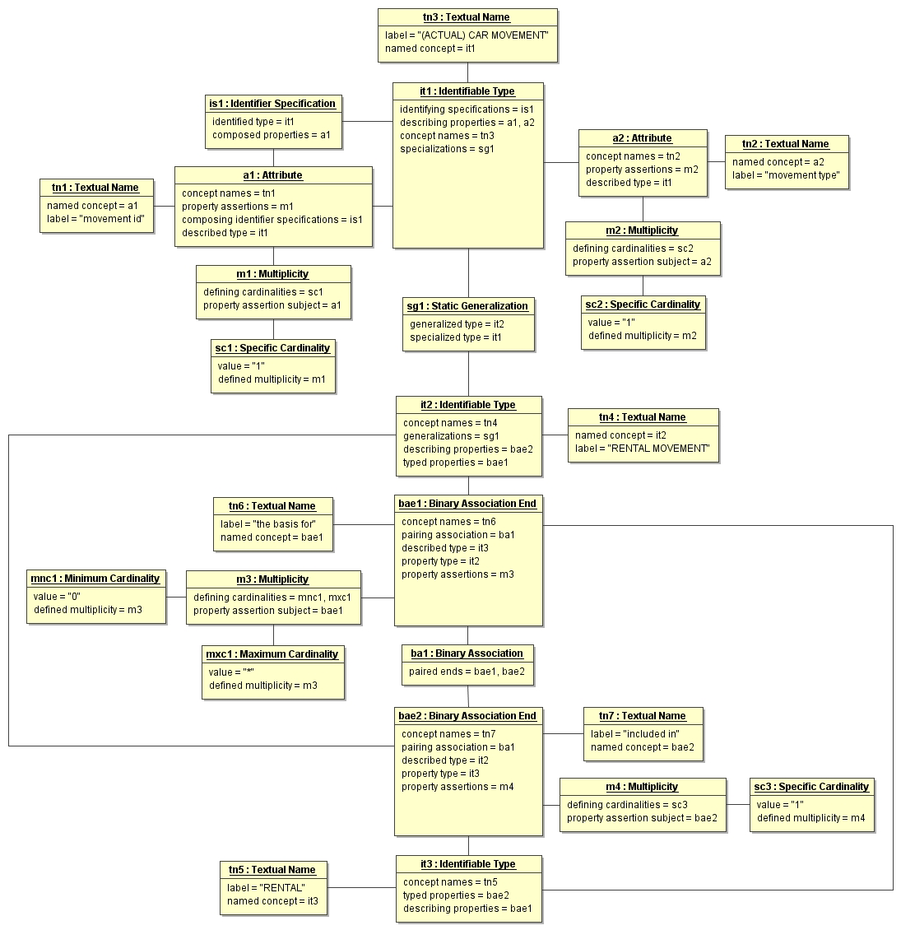
Figure 25: ER Model of EU-Rent Example

This section is based on a similar description of the Architecture Framework in David C. Hay, Requirements Analysis: From Business Views to Architecture. Prentice Hall:Englewood Cliffs, NJ. 2003. Used with permission.
Framework Diagram from Hay, D. Requirements Analysis: From Business Views to Architecture. (Upper Saddle River, NJ: Prentice Hall PTR) Copyright © David C. Hay. Used with permission.

